|  |
| --- |
|  |
| ***Charnwood Country Residence Newsletter***  **Febru*ary* 2022**  No photo description available.  **Much Dewchurch, Hereford HR2 8DL**  **Tel :- 01981540291** |
|  |

We would like to congratulate Lindsay on recently becoming our Home Manager.

We feel very lucky to gain such a compassionate and caring Manager to oversee the running of our special home.



***Welcome to the next edition of our newsletter. This a great way to share up to date news and some of the meaningful ways we spend our time. We hope that you will enjoy receiving this and any feedback, or suggestions on content is always gratefully received. Email*** [***b.powell@herefordshirecarehomes.com***](mailto:b.powell@herefordshirecarehomes.com)

***Join us on our Facebook Group for day to day updates on the activities we take part in and other aspects of our daily living***

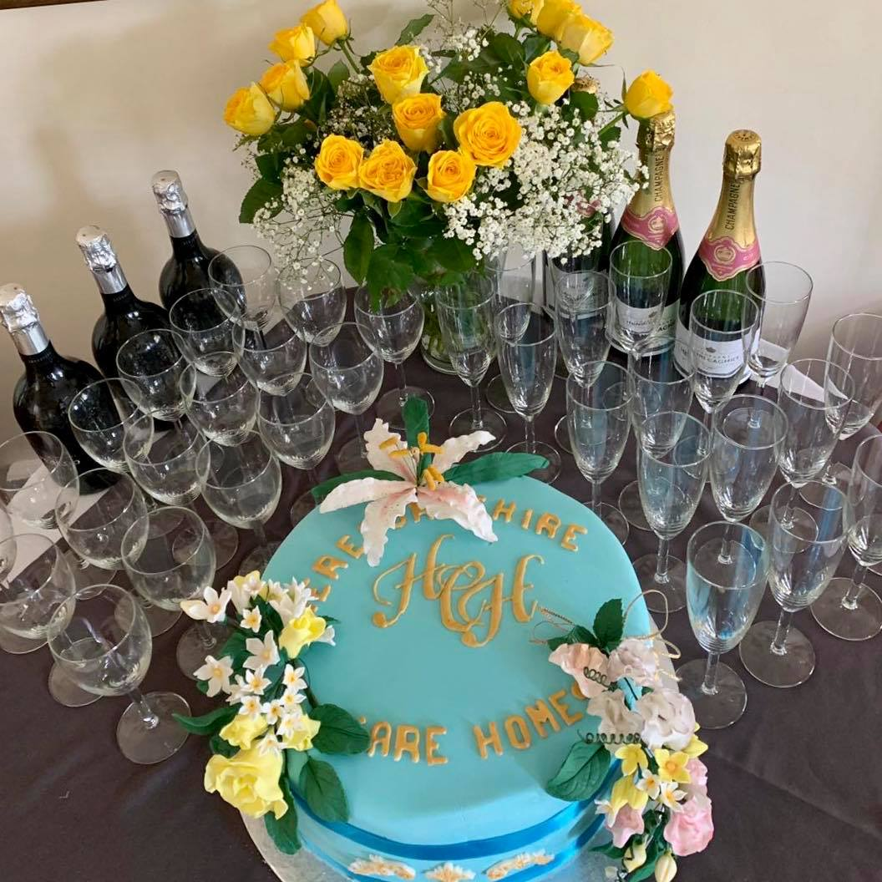

|  |
| --- |
|  |
|  |

February has arrived, and we have a busy month ahead. Dignity Action Day is always acknowledged in a big way at Charnwood, not just on the day but throughout the year. We hold monthly Resident’s Meetings, where all aspects of care and daily living are discussed, with dignity being a major topic. What is dignity? What does it mean to me? What should I do if I feel I am not being treated in a dignified manner? What should I do if I witness somebody else not being treated with dignity? All of these questions are asked to our residents. (Please check out our Dignity Video, which was posted on our Facebook page!

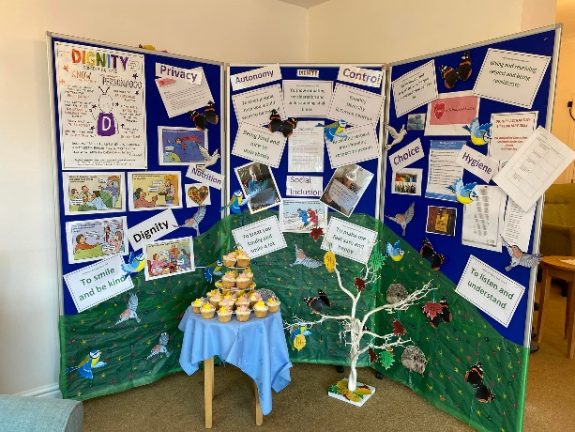 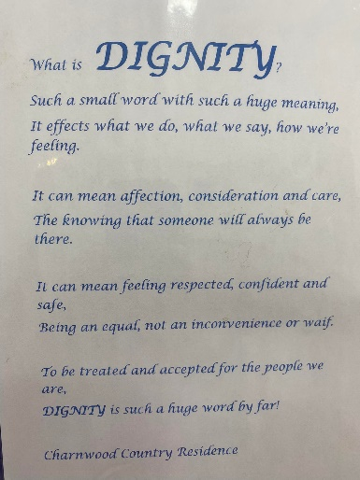 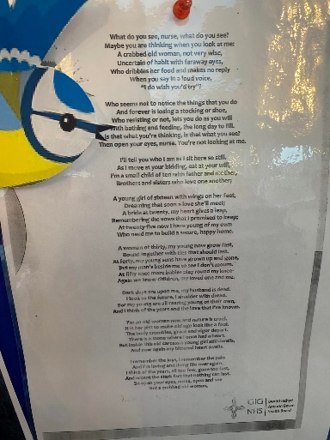

**Let’s take a look at our month gone by ….**

We celebrated National Shortbread Day by treating ourselves to a selection of traditional and flavored shortbread, along with the choice of a tot of Baileys or a coffee topped up with a splash of Baileys 🤣❤️

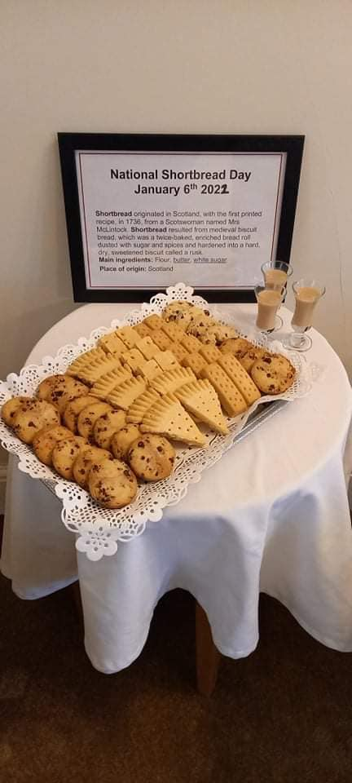 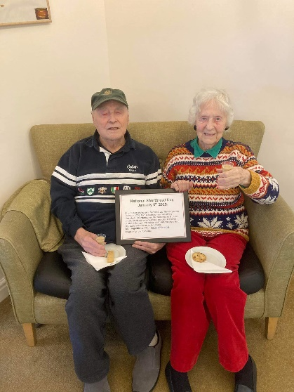 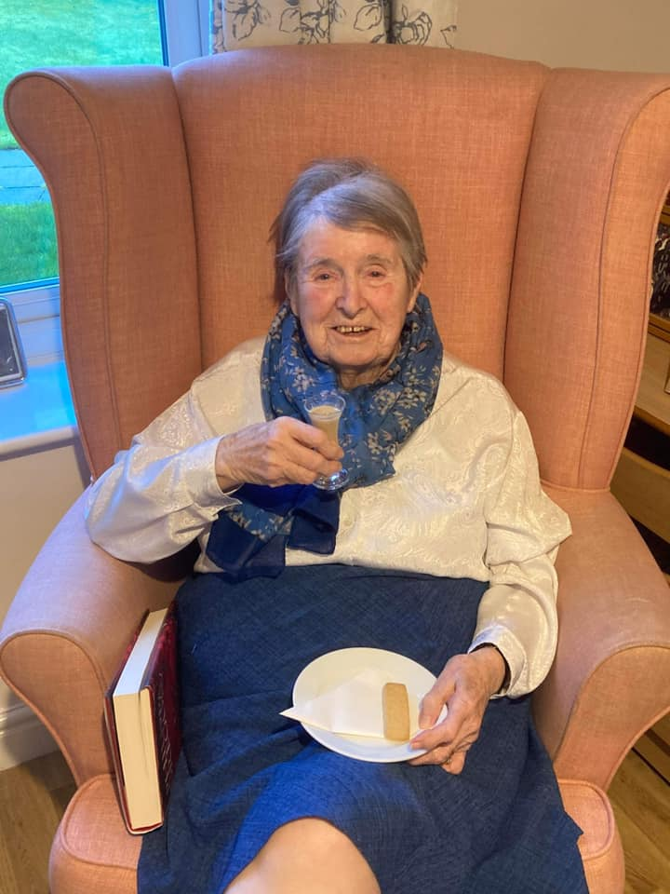 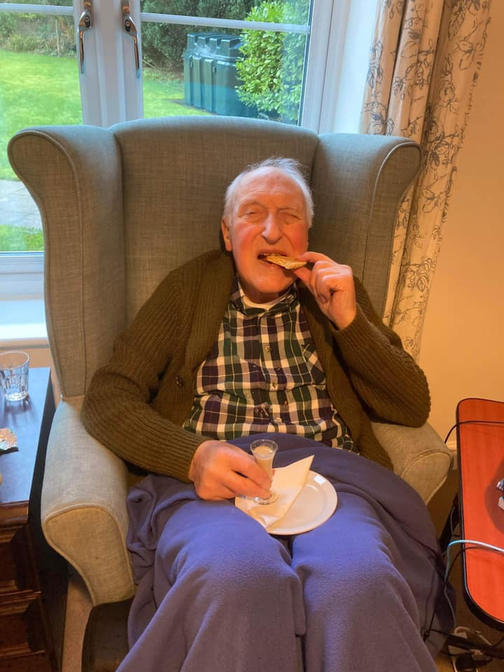

We have enjoyed a selection of games to keep us moving, remembering and smiling!

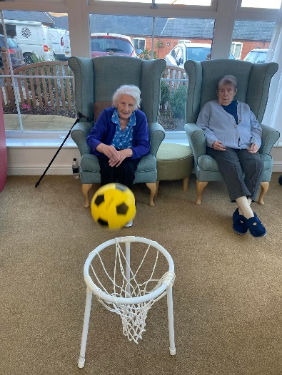 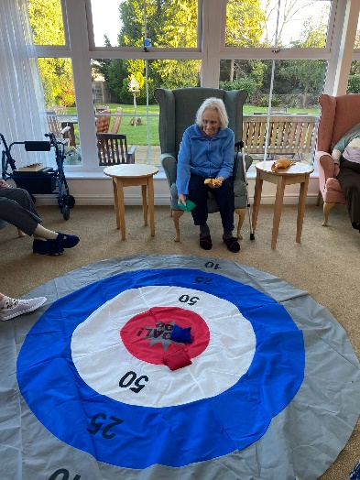 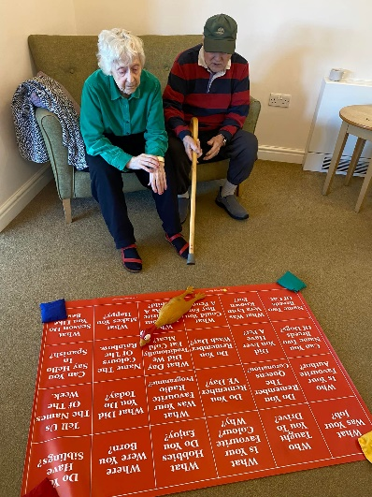 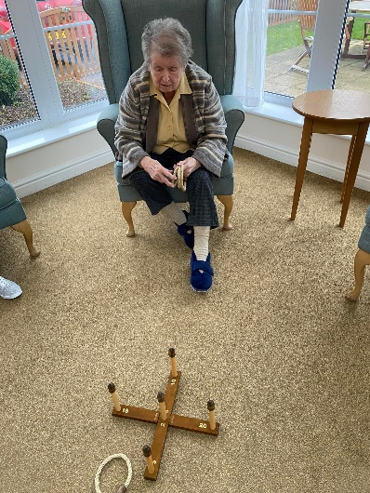

We celebrated Burn’s Day/ night, with some traditional Scottish food, history, facts on Robert Burns and Scotland and music ❤️

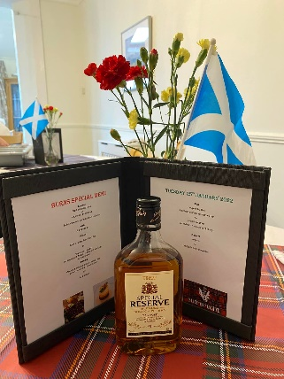 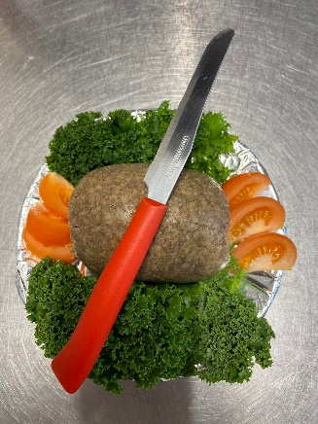 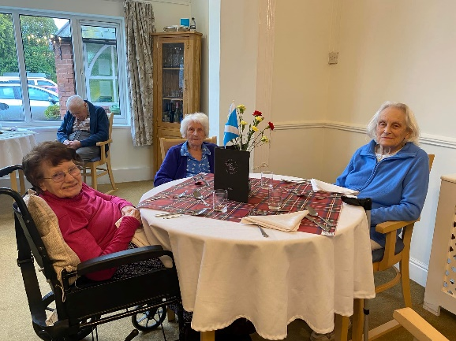 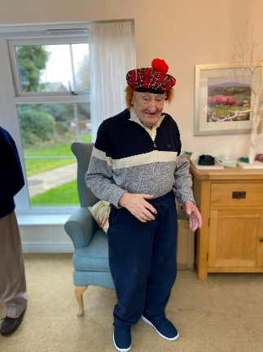

We celebrated Australia Day, with many facts, artifacts, traditional food and some music from Kylie and Jason! ❤️

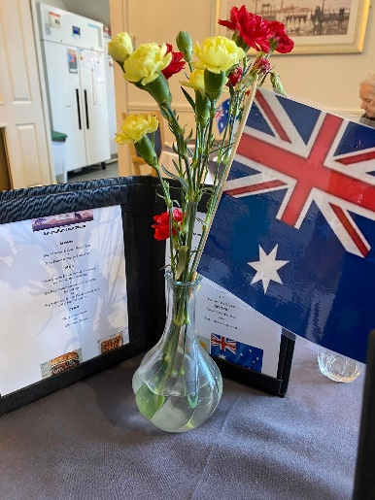 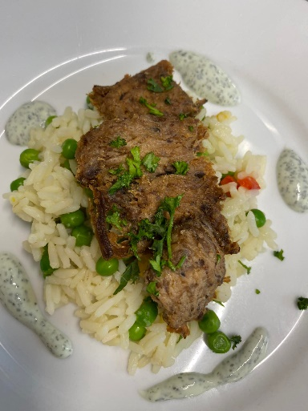 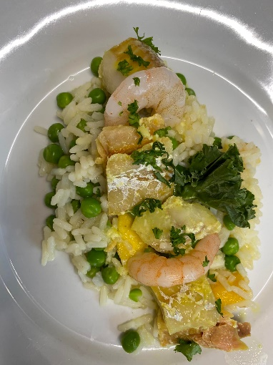 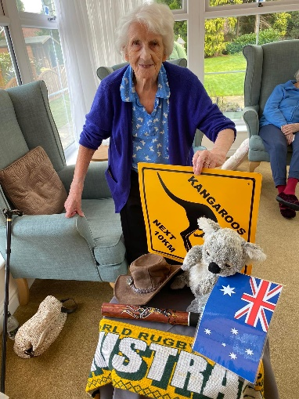

We celebrated some special birthdays!

We hope you enjoyed your special days Jan, Sheila and Dennis!

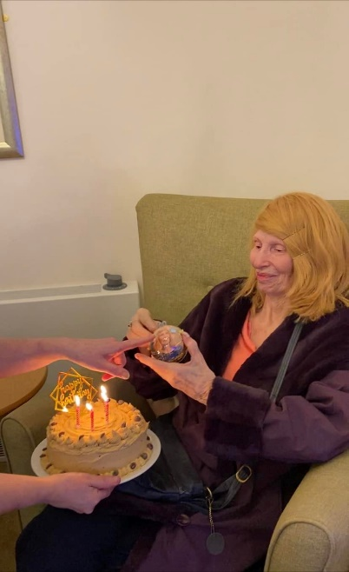 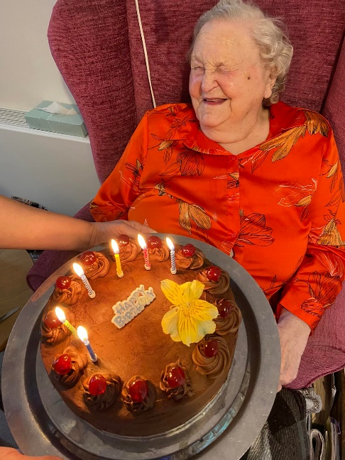 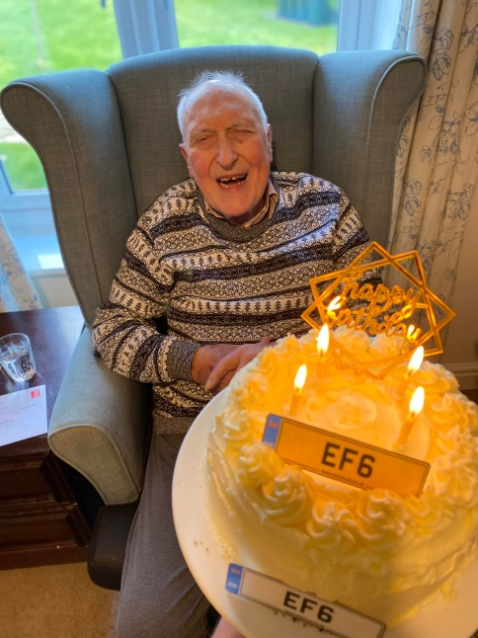

And enjoyed the odd tipple…

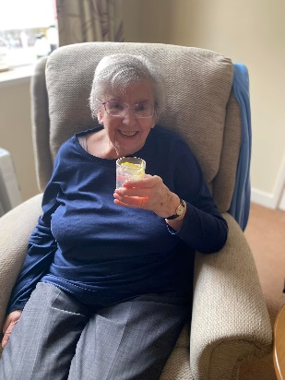 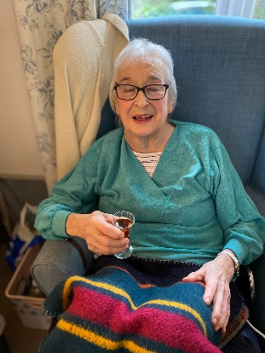 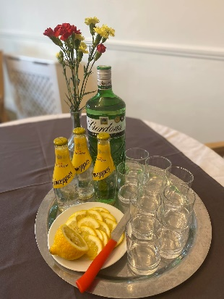 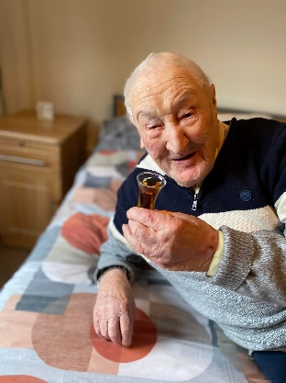 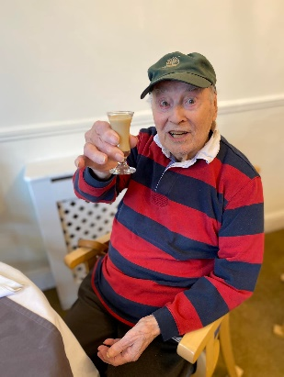

Up and coming events…

1st Feb Dignity Action Day

7th Feb A morning of Celebration

14Th Feb Valentine’s Celebrations

Date Tbc Equality & Diversaty acknowledgement inc a Mad Hatter’s Tea Party

*Our Monthly Resident’s Meeting, many more arts and crafts opportunities, Sing a longs, ball games and village walks. Weekly exercise, poetry mornings, praise services, quizzes, reminiscence, flower arranging and bingo sessions.*